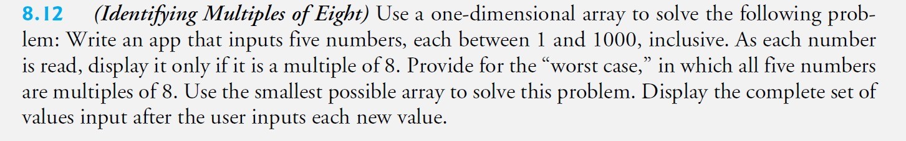
Q1: Implement the following pseudo-code in Go:
PROCEDURE MoveZeros(A)
n ← length(A)
insertPos ← 0

FOR i ← 0 TO n - 1
IF A[i] ≠ 0 THEN
A[insertPos] ← A[i]
insertPos ← insertPos + 1
END IF
END FOR

WHILE insertPos < n
A[insertPos] ← 0
insertPos ← insertPos + 1
END WHILE

RETURN A
END PROCEDURE

